ICT worksheet
Tasks sheet
Topic  Hardware components  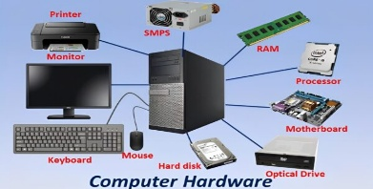 | Employability Reference  IT Technician – works to setup, configure, fix and troubleshoot IT systems  Technologist – Designs, analyse, recommend upgrades and adoption of systems  Computer programmer – electronically writes instructions and steps for systems  Computer Operator- works as end user to power up and provide computer services  Competences  Identify and describe hardware components and functions of a basic computer system.

Name of student  Sicelo Dlamini | Task1  Using a set of screw drivers disassemble and assemble an old desktop computer | Task 2  Draw or snap shot and labell the computer parts | Task 3  Explain the functions of each computer part
Outcome  Learner differentiates components of a basic computer system by design, colour, shape and functions |  | Core Skills  ICT Skills  Thinking, Skills  Research Skills |  | Entry Behaviours  Information evaluation  Ability to compare  Using screw drivers  Copy and paste |  | Date  12/10/202578543

Background
A computer system is made of hardware and software. The hardware components include input devices, output devices and processing devices. The connection and location of these devices in a computer system depends on their functions in the IPO scheme.
Answer sheet
Separate components of a computer system | Function of each computer component and parts
Application
What can IT Technician do if a computer system does work pproperly?
.
Lesson learnt / Recommendations
IT Technician
Technologist
Computer programmer
Computer Operator

Signatures
Grade | Resources used  https://thetech.com.vn/en/summary-of-computer-components-you-need-to-know/  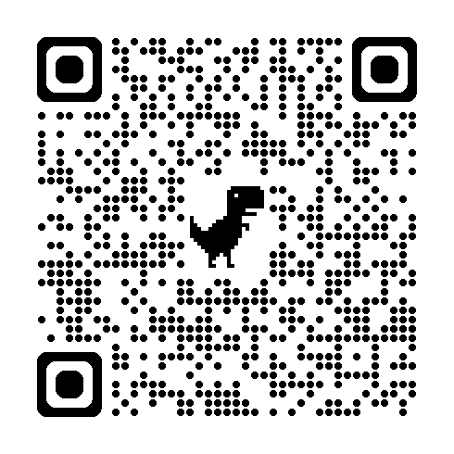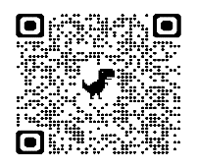
Signature by student  Signature by Teacher  Signature by Parent |  | Lesson Date 20/03/2025

